 | Ash, Ash Vale & Ash Green  Community Safety Update
Date: March 2013
We are your  Community Safety Wardens  for Ash Parish    LESLEY TELFORD  To phone me:  07769 642053  To E-mail me:  Lesley.telford@guildford.gov.uk    JO PACKMAN  To phone me:  07901 513652  To E-mail me:  jo.packman@guildford.gov.uk  We are part of the Community Safety Team in Ash Parish with:  PC VANESSA PRIVETT  Ash South & Tongham  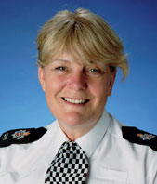  PCSO Susana Robinson  Ash South & Tongham  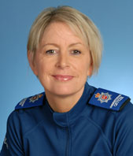  PC GARY WATSON  Ash Wharf    PCSO MORGAN WEBB  Ash Wharf  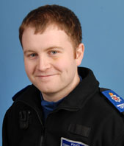  PC CHRISSI THOMAS  Ash Vale  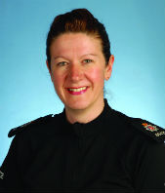  PCSO STEFANIE QUIRK  Ash Vale  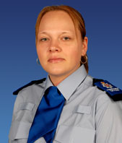  All of the above can be contacted by email on:  wsguildfordsnt4@surrey.pnn.police.uk  IF A CRIME IS IN PROGRESS  999  SURREY POLICE  (NON URGENT)  101  PARKS RANGERS  Mob: 07880 784947  GBC CLEANSING HOTLINE  01483 444499  CRIMESTOPPERS  0800 555 111  www.saferguildford.org.uk  Community Safety Wardens play an important role by being the bridge between the community and the Council  “Please contact us if there is any issue that you think we could help you with.” | Please contact us to request this document in an alternative format or language  List of contents  - Introduction  - Dates for your diary  - Ash CAB Quiz Night  - Community Safety Survey  - Ash In Bloom 2013  - Bike Clinics  - Easter Egg Collection  - Puttenham Bowls Club – Open Day  - Introduction  Welcome to our March newsletter. Just when we thought the cold weather was over!!!! Wrap up warm and keep an eye out for our elderly residents who may have problems getting out and about.  - Dates for your diary  Neighbourhood coffee morning – Wednesday 3 April 2013 10am to 12noon at the Victoria Hall, Ash Hill Road, Ash. Come along to the coffee morning and have a chat with your local Police Officers and Neighbourhood Team. This is a regular event on the first Wednesday of each month. Refreshments are free but a voluntary donation can be made to the Victoria Hall as they are currently raising funds for urgent restoration work.  Ash Wharf Neighbourhood Panel Meeting – Next one on Tuesday 14 May 7.30pm at The Ash Centre, Ash Hill Road, Ash GU12 5DP.  Ash Vale Neighbourhood Panel Meeting – Next one on Wednesday 27 March 2013 7.30-9pm. St Mary’s Church, 203 Vale Road, Ash Vale GU12 5JE.  Ash South and Tongham Panel Meeting – Next one on Monday 11 March 2013 7.15-8.15pm at St Paul’s Infant’s School, The Cardinals, Tongham, Surrey GU10 1EF.  Ash South Community Policing Clinic – First one on Thursday 21 March 3-4pm at The Holy Angels Church, 65 Ash Church Road, Ash GU12 6LU. Come and speak to your local Officers PC Vanessa Privett and PCSO Sue Robinson about any local concerns  Coffee morning – every Friday 9.30am –1pm at The Chapel, Wharf Road, Ash Vale. Pop in any time for a tea, coffee and cake. It’s all free. A good opportunity to make new friends and meet old ones!  The Ashes Good Neighbours are holding a Coffee Morning on Wednesday 17 April at 10am at The Victoria Hall, Ash Hill Road, Ash. If you would like to know more about the scheme, please pop along and join them for a friendly chat and coffee. If you want to know more about the scheme, you can email: ashes-gn@hotmail.co.uk  __________________________________________  - Ash CAB Quiz Night  Ash CAB is holding a Quiz Night on Saturday 18 May at The Ash Centre, Ash Hill Road, Ash, starting at 7.30pm. Teams of 6 people required. If you cannot make up a team, please still go along and they will arrange one for you. The cost is £10 per head, which will include a Ploughman’s Supper. Please bring your own drink. To book your place, please ring The Citizens Advice bureau on: 01252 315569  ___________________________________________  - Community Safety Survey  A big thank you to all who took the time to complete our 6 monthly survey. We will let you know the results of the survey as soon as they become available.  - Ash In Bloom 2013  You may not believe it, but Spring is just around the corner and soon Summertime will be upon us! Once again, Ash Parish Council is holding its Ash in Bloom competition.  Why not join in yourself, or nominate a neighbour, friend or other Parish resident by entering one of the five categories and maybe win yourself or your nominee a prize and certificate. The categories are:  - Best Hanging Basket  - Best Tub/Container  - Best Garden Border  - Best Front Garden  - Best Kept Allotment  Entry is free and judging will take place in July.  For an entry form or further information, contact the Ash office on: 01252 328287 or email  office@ashpcsurrey.gov.uk or website www.ashpcsurrey.gov.uk  - Bike Clinics  Bring your bike along to one of the Bike Clinics that are being held over the Easter holidays. For free hands on maintenance and repair training, come along to see our ‘Dr Bike’ at 10am to 12 noon on Thursday 4 April and Thursday 11 April at the Ash Skate Park, Ash Hill Road, Ash.  For more information contact Matt Smith at First Wessex Housing on: 01252 368735  - Easter Egg Collection  Your local Budgens store is collecting Easter Eggs for Shooting Star CHASE. So next time you pop in, why not buy an extra egg and donate it to this worthwhile children’s hospice service. There will be a collection point at the store until the last Saturday before Easter (23 March).  - Puttenham Bowls Club – Open Day  Would you like to play Bowls? Puttenham Bowls Club invites you to visit their green on Sunday 14th April to try your hand at bowling for fun in friendly company. Start time 2:30pm. They are a small village club that has been established for 85 years and they bowl from May to September in a lovely setting next to the 18th Green at Puttenham Golf Club (GU3 1AL for Satnavs). Bowls will be provided and you can enjoy a cup of tea and refreshments afterwards.  For more information you can contact the following:-  Fred Harrison 01483 235368  Gill MacBean 01483 233573  John Thody 01252 325510  Muriel Brock 01483 811839  Please pass this message on to anyone whom you think would like it. If you have any community notices that you would like included in this newsletter, please email us details and we will try and fit your information in.  Best wishes  Lesley and Jo

