Contact:
Phone:
Fax:
Email:

Our ref:

To Councillors,
Parish Clerks,
Residents Associations,
Guildford Borough Council officers
and community planning participants

July 2012
Mary Anne Pryor
01483 444463
01483 444646
maryanne.pryor@guildford.gov.uk

Community Ideas Database

Dear Sir/Madam

We need your ideas for the Community Ideas Database (CID)
We are writing to you for the annual update of our Community Ideas Database. This database aims to capture the community’s ideas for small environmental works in the local area. These may then be funded by a future Section106 legal agreement negotiated as part of a planning application.
We are looking for ideas for smaller environmental projects that could reasonably be requested in connection with a development such as:
- lighting
- seating
- planting
- play areas and
- road safety measures.
This database offers a key opportunity for local people to put forward their views on improvements required in their area. This is not a statutory or adopted planning document and there is no guarantee that appropriate funding from relevant planning applications will be negotiated. However, planning officers check the list to see what ideas have been put forward and the ideas may then inform our negotiations with developers.
Please send us new ideas and let us know if previous suggestions are still relevant. I have attached a spreadsheet downloaded from the database to help with your reply. Click on the down-arrow in the title row of the spreadsheet to filter the ideas to get the right ward and see the ideas already in place. Then please confirm:
- improvements you would like to see – both new ideas and previous ideas that are still wanted
- improvements you feel should be deleted as they are no longer required
- improvements completed using other funding streams.
Please let me know your views by 30 September 2012.
Ideas need not be restricted to this database but could also form, for example, part of our minor works list. Our finance service sent a letter at the end of May to parishes asking for spending ideas for the concurrent function grant. The Community Ideas Database is completely separate from this grant.
I look forward to hearing from you and would like to take this opportunity to thank you for your time and input.
If you have any queries please do not hesitate to contact me on the contact numbers given at the top of this letter.

Yours faithfully

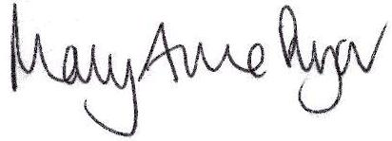
Mary Anne Pryor
Section 106 Officer
Maryanne.pryor@guildford.gov.uk

Enc. Current information from the Community Interest Database

